# DC Resistive Network Analysis

## Introduction

### Intended Learning Outcomes (ILOs):

1. Review of basic skills; KVL, KCL, Ohm's law
2. Details of resistive network analysis (analyzing circuits containing only sources and resistors). If you use phasors, the techniques here can also apply to AC steady-state analysis for networks containing resistors, capacitors, and inductors, so it's more general than it sounds at first. Skills and info to be gained:
   1. Node Analysis (Method to analyze resistive networks)
   2. Mesh Analysis (Method to analyze resistive networks)
   3. Superposition (Method to analyze resistive networks which relies on linearity)
   4. Thévenin & Norton Equivalent Circuits (Methods for simplifying source networks)
   5. Further Study (beyond scope of tests): Maximum Power Transfer (Information about impedance matching to get the most out of a source network)

Note that applying KVL & KCL is also a circuit analysis method, and unlike some of the other methods doesn't itself rely on linearity. While it is a valid method and perhaps the easiest to understand why it works, it's typically not as fast as the methods above. Each of the above methods is best for a particular type of circuit.

Here's the sort of circuit you'll be able to analyze after this topic:

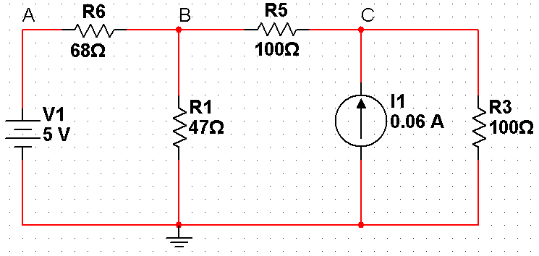

### Topic 1 Videos:

1. Multisim & DC Resistive Analysis Intro: <https://www.youtube.com/watch?v=vdhn3GjsbKs&list=PLhbHWgMknRJT_eKLFXB843NkaNHfJ37Pw&index=1>
2. Nodal Analysis: <https://www.youtube.com/watch?v=hSNeqDJe-qE&list=PLhbHWgMknRJT_eKLFXB843NkaNHfJ37Pw&index=2>
3. Mesh Analysis: <https://www.youtube.com/watch?v=rXIFmaLHj4M&list=PLhbHWgMknRJT_eKLFXB843NkaNHfJ37Pw&index=3>
4. Superposition: <https://www.youtube.com/watch?v=FwuC_7JMQzQ&list=PLhbHWgMknRJT_eKLFXB843NkaNHfJ37Pw&index=4>
5. Thévenin Equivalents: <https://www.youtube.com/watch?v=QxzSa_TZe4o&list=PLhbHWgMknRJT_eKLFXB843NkaNHfJ37Pw&index=6>
6. Max Power Transfer: <https://www.youtube.com/watch?v=Qjxi5SfMjrM&list=PLhbHWgMknRJT_eKLFXB843NkaNHfJ37Pw&index=7>
7. Lab Skills Videos:
   1. <https://www.youtube.com/watch?v=JrveDVs2fCQ&list=PLhbHWgMknRJT_eKLFXB843NkaNHfJ37Pw&index=5>
   2. <https://www.youtube.com/watch?v=AqybJURSgKU&list=PLhbHWgMknRJT_eKLFXB843NkaNHfJ37Pw&index=8>
8. Hantek Lab Modification Videos:
   1. Lab kit unboxing vids: <https://www.youtube.com/watch?v=bukI2s27PEg&list=PLhbHWgMknRJT_eKLFXB843NkaNHfJ37Pw&index=9>
   2. DC Voltage measurement: <https://www.youtube.com/watch?v=Q4SASV0s88I&list=PLhbHWgMknRJT_eKLFXB843NkaNHfJ37Pw&index=12>
   3. Full lab 1 Hantek modification version: <https://www.youtube.com/watch?v=NsR1MMAEOnU&list=PLhbHWgMknRJT_eKLFXB843NkaNHfJ37Pw&index=13>

### Deliverables

Note: As always, your full objective for this topic is to review these notes, the videos, practice problems, live class sessions and forum content, then to write-up creating and tri-solving a variation problem of the week's topic that demonstrates you've mastered the content. With that all still in mind, following are some specific guidelines & tips for this week.

See the Outline and Deliverable Rubric files for information for the write-ups in general. Specific tasks for your H1 deliverable are as follows:

1. Design a circuit using resistors and your power distribution board (header board from the component kit) that has
   1. Two voltage supplies (one 5 V and one 3.3 V) which have their low sides connected to ground (having them connected is mandatory because the header board has the low side of each supply connected together already. Defining it as "ground" for your circuit is not mandatory, but it will help keep things a bit consistent)
   2. At least 5 resistors that are at least 1k (need high enough resistance of a load to avoid shorting your supply)
   3. At least 3 meshes
   4. No shorting of the power supplies (putting a low resistor or wire across the supply or any too low of a resistance path from one end to the other) or making them fight (putting the two voltage supplies in parallel)**
2. Make your tri-solve objective to find:
   1. at least two nontrivial currents and
   2. at least three nontrivial voltages in your circuit.
3. Analytically solve your circuit 4 separate ways:
   1. using Kirchoff's laws,
   2. mesh analysis,
   3. nodal analysis, and
   4. superposition.
4. Use Multisim to model your circuit and measure the target voltages and currents. Do this using multisim's voltage and current probes and using the multimeters.
5. Physically build your circuit on the breadboard and measure the same voltages and currents (**Note: watch all of the above videos and review the rest of these notes before doing any of the steps, but especially the physical build, because you can break, burn, or even explode your equipment and seriously hurt yourself and your house if you use it wrongly enough**).
   1. Note: remember that your multimeter is an open in voltmeter mode, a short in ammeter mode, and applies a voltage in ohmmeter mode. The most common problems people have are 1) trying to measure resistance in an assembled [or worse, assembled & powered] circuit; and 2) accidentally putting an ammeter in parallel with something and shorting it out, possibly breaking their power supply.
   2. Note: For all measurements, include uncertainty due to the instrument you're using on the setting you're using it.
   3. Note: Take a picture of your student card and your finished circuit together. Mark this up to explain how it's implementing your desired circuit (i.e., which resistor and supply are which).
   4. Note: Take a picture of the multimeter output for all measurements.
   5. Before wiring up the circuit, measure all resistor values
   6. Measure the voltage outputs of the supplies while the circuit is operating; if they drop by more than a few percent you have a short (or are drawing too much current because your resistors are too small).
   7. Get your current measurements two ways:
      1. by using the ammeter, and
      2. by measuring a voltage across a resistor in that branch where you want the current and using Ohm's law.
6. Write this all up in a clean report that satisfies all the steps in the rubric; e.g., includes an analysis section comparing [and reconciling] the results and a reflection on the topic and its applicability.

Hints:

1. Consider the resistor values you actually have in the kit before deciding on your resistor values. You can even measure them at the start and use the measured values as your selected resistance for your sample circuit. Alternatively, you can update the values in the sample circuit to the measured values and recalculate & resimulate like I do in the video.
2. Don't draw the circuit by hand; use the image from multisim and mark that up with a paint program; it's faster (once you get used to it) and will make your writeup look much better.
3. When comparing your results, ensure you are comparing the same things. e.g., if your actual measured supply voltages and resistor values were different than ones used in your analytical calculation & simulation, you need to update those and recalculate & re-simulate before comparing.
4. Propagating the error in voltage or resistance measures in this calculation is difficult because the calculation involves solving a linear system. With Maple you can solve the system analytically and deduce the impact of uncertainty in various quantities. You can also test how well the error propagation formula works here by re-calculating quantities using maxes and mins of measured ranges to determine the range on the output values.

**What does *"No shorting the supplies or making them fight"* mean??

Here's V2 shorted:

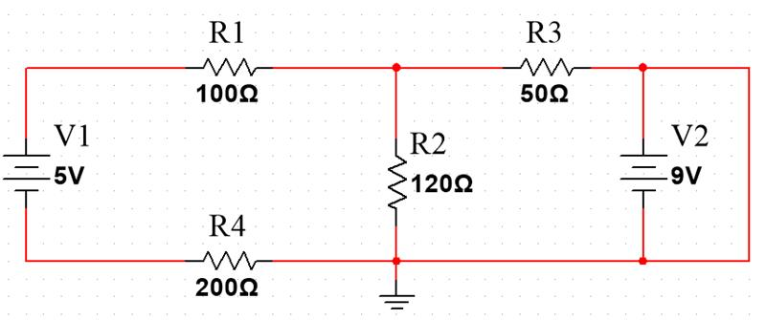

(there's a wire, AKA a short circuit, connecting each side of V2 so there's a short cut for current around it. Since it's a supply, it'll try to put infinite current to maintain 9V and will actually reach a current limit at close to 0 V (the wire will win the fight). Since it's not a good supply, your kit's supply will overheat and break when it does this)

Here's V2 fighting V1:

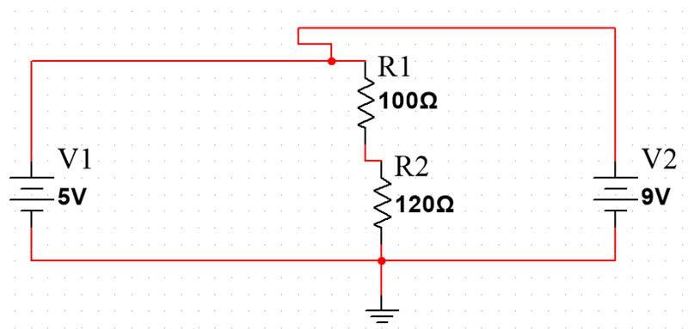

(V1 says the voltage at the top is 5 V, while V2 says it's 9 V. They're in parallel, so will compete, and each try to put out infinite current to make that happen. In reality they can't, so will reach some current limit at a different voltage, as when they're shorted, and will likely overheat and burn out.)

## Electricity and Circuit Fundamentals

This chapter focuses on details of resistive network analysis (analyzing circuits containing only sources and resistors). If you use phasors (Chapter 4), the techniques here can also apply to AC steady-state analysis for networks containing resistors, capacitors, and inductors, so it's more general than it sounds at first. First we will go over some background information which you should know already from previous courses.

### Symbols

Below are the main passive and active circuit elements you will be dealing with in this class:

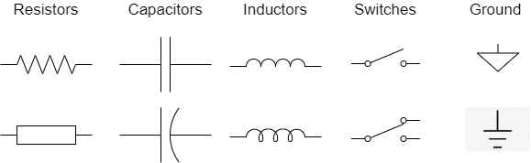

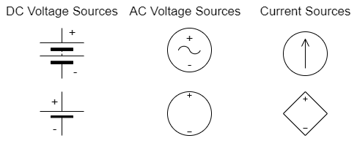

[note: In this class we deal with ideal sources and ignore imperfections that are associated with real-world power supplies. The symbols above indicate ‘ideal’ sources]

### Terminology and Definitions

**Voltage:** Represented with the symbol (*V*), voltage is the measure of potential difference between two points in a given circuit. Measured in volts (V).

**Current:** Represented by the symbol (I), current is the rate of flow of electric charge, traditionally this is specifically the flow of positive charge. Measured in amps (A).

**Power:** Electrical power is the rate at which energy is dissipated across an element or load. Measured in Watts, which is equivalent to Joules/second. (W or J/s).

**Ideal voltage source:** always has its set voltage across its terminals (i.e., an ideal 5 V source supplies any current necessary to make its positive terminal 5 V higher than its negative terminal)

**Ideal current source**: always supplies its set current (i.e., an ideal 2 A current source produces any voltage necessary across its terminals to supply 2 A.)

**Ground**: An electrical connection of a circuit or conductor to the earth. The node attached to the ground is used as a reference voltage of 0V.

**Branch:** A group of elements along a single path.

**Node:** A point at which lines or pathways intersect or branch; a connecting point. The image below has labelled all nodes in the circuit.

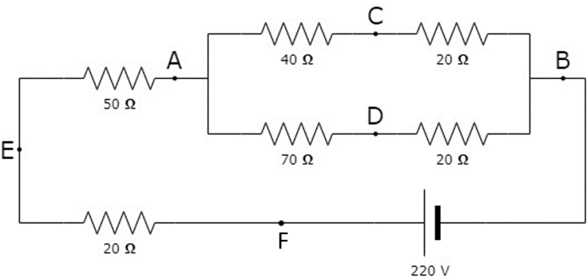

**Mesh:** A closed path around a circuit (contains no smaller closed paths)

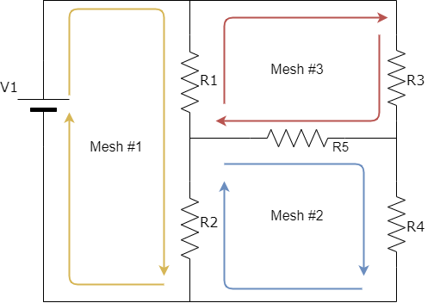

**Loop**: Any closed path (physical or ortherwise). This implies that all meshes are loops, but not all loops are meshes.

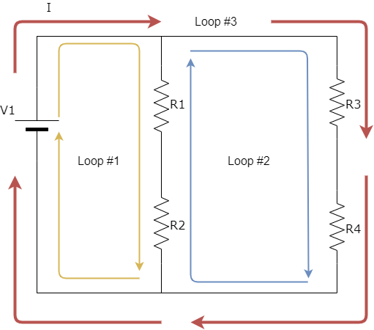

**Parallel elements:** elements are *in parallel* with each other if they are between the same two nodes; i.e., the voltage across them must be equal.

**Series elements:** elements are *in series* with each other if they are in the same branch; i.e., the current through them must be equal.

**Network Analysis:** Determining all the unknown branch currents & node voltages.

Steps are as follows:

1. Define all the relevant variables (i.e., currents in and voltage across branches)
2. Use one of the analysis methods detailed below to write equations (sections 3.2, 3.3, or 3.5)
3. Solve the equations for the variables.

*Note: if a variable is negative (usually current, but can be voltage),* ***do not*** *go back and redefine it so it's positive because all your equations will be backwards. Saying "I2, the current flowing left to right through the resistor, was negative 3 mA." is completely fine (it's the same as +3 mA flowing from right to left). This also means you shouldn't stress about which way to choose for the current variable directions in each branch (but once you've picked them you do need to be careful to write the voltage changes across resistors in terms of them correctly!)*

### Ohm’s Law and Passive Sign Conventions

Ohm’s law states that the current through a circuit element is proportional to the voltage difference across that element: 

This is more complicated than it sounds, because the values for voltage and current are both directional (not scalars!).

See the figures below for the sign conventions applied to passive circuit elements (a capacitor, resistor, and inductor, respectively), i.e., the "passive sign convention":

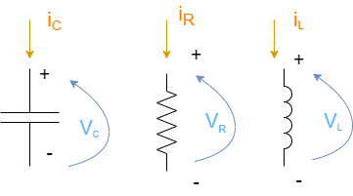

This diagram explains what Ohm's law is talking about; when we say for a resistor that  the *V* we mean is specifically the voltage rise from the side the current *I* **exits** from to the side the current *I* **entered** from, as shown.

### Kirchhoff’s Voltage and Current Laws (KVL, KCL)

**Kirchhoff’s Voltage Law**: The sum of voltage drops within any closed loop is equal to zero.

**Kirchhoff’s Current Law**: The sum of current’s entering a node or junction is equal to the sum of currents leaving that same node.

Using these you can set up equations to solve for unknown currents or voltages in a circuit.

Example: Find the voltage across and current through R2 in the following circuit using Kirchoff's Laws:

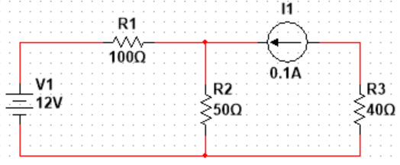

Solution:

Define branch currents (direction is arbitrary, but stick with it once you've got it):

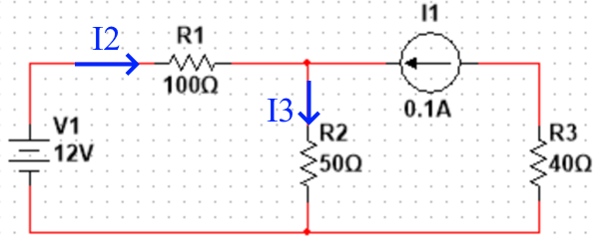

Apply the passive sign convention: Draw a '+' sign on the side the current entered from to remind you make sure you don't use Ohm's law backwards later

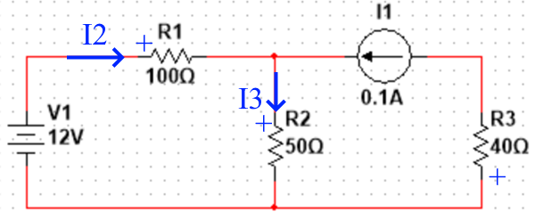

Next, write in the voltage change variables across all elements:

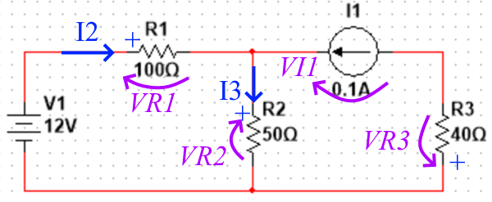

Note: this doesn't mean the voltage at that side is actually positive, just that (as long as *I2* is positive) that the side of *R1* it's entering is at a higher voltage than the other side, and more specifically, that the voltage from **right to left** across R1 is .

Note 2: For the current source, we assign its voltage in the direction so that positive *VI1* would mean it's actually supplying power. If *VI1* ends up being negative it means this supply is in fact dissipating power. Resistors always dissipate power but a current source could be supplying or dissipating it depending on how the circuit is set up (e.g., a battery usually supplies power by pushing current out the positive terminal but when you charge it you force the current into this terminal and it absorbs power instead).

Then to solve, you apply KCL at all the nodes that join more than 2 paths except for one, apply KVL around each mesh, and apply Ohm's law to relate the passive voltages to the currents through them:

KCL (at the top-centre node):



KVL at the left and right meshes:



Ohm's law for the passives:



All together, this is 6 equations with 3 currents, 5 voltages, and 3 resistances. Since we know the resistances, *V1*, and *I1* that leaves 6 unknowns.

Often we'd simplify things when writing by applying Ohm's law while writing the KVL equations to put everything in terms of current from the start:

KCL: 

KVL:



To find , we can apply just the first 2 equations since we know  and :



Then 

Note: the solution for the current through and voltage across *R2* each end up being the sum of a term proportional to the voltage supply and a term involving the current supply. This isn't a coincidence, and is actually the basis for the superposition method of analyzing circuits we'll look at shortly.

Substituting in the numbers we get



  
  
Example Maple calculation of this result:  
**> restart:**

**V1:=12: I1:=.1:**

**R1:=100: R2:=50: R3:=40:**

**solve([**

**I2+I1=I3,**

**V1=VR2+VR1,**

**VR2+VR3=VI1,**

**VR1=I2*R1,**

**VR2=I3*R2,**

**VR3=I1*R3]);**



## Advanced Circuit Analysis Techniques

### Nodal Analysis

Method:

1. Assign a reference node to be 0 V (the "ground"). This node typically has the most elements tied to it.
2. Assign variables to the voltage of each of the other nodes (relative to the ground),
3. Write KCL at each of those nodes (i.e., not the ground node) immediately converting currents into expressions in terms of the node voltages (this basically combines KVL & KCL in one step so you have less equations to solve later)

Super node Exception:

Any nodes separated by a voltage source should be combined into a "super node" for steps 2&3.

E.g., for a 5 V source between nodes 2 & 3, only assign one variable (e.g., instead of "v2" & "v3" call it "v2" and "v2+ 5 V"), then write KCL for the combined super node.

*[Note that this means if a voltage source is attached to ground on one side it immediately determines a node voltage, so you do not need to write an equation for it.]*

Example: Find the voltage across and current through R2 in the following circuit using Nodal Analysis



Assign the bottom node to be 0 V, and the top centre node to be v2.

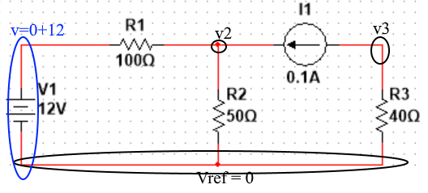

Then KCL at the top says

 (note that the top left of the circuit is a super node with the ground so we don't need a new variable for it, and that since we're applying KCL in nodal analysis we can immediately write the current source current as 0.1 A rather than mess with the voltage at the top right of the circuit. (If we needed the voltage at the top right of the circuit we could look at that point as its own node and write another equation there.)

Solving:



And so 

Here is another circuit solved via node analysis (Taken from sample lab 1):

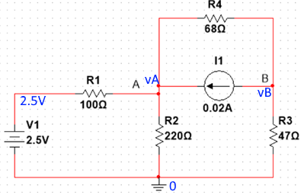



### Mesh Analysis

Method:

1. Assign a "mesh current" to each mesh, then;
2. Write KVL around each mesh in terms of the mesh currents.

Supermesh Exception:

Any meshes with a current source in the branch between them should be combined into a "supermesh" for steps 1 & 2; use the current source to define one current in terms of the other immediately. If the current source is on an exterior edge of the circuit you can instead use it to immediately determine a mesh current and avoid a variable that way.

Example: Find the voltage across and current through R2 in the following circuit using Mesh Analysis



Solution:

Assign mesh current variables; whichever direction you like is OK.

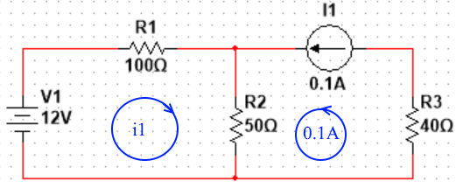

(Note that because of the current source we do not need a variable for the 2nd mesh current)

Write KVL around the left mesh:



Solve:



and the current through R2 is 

meaning the voltage across it is 

Here is another circuit solved via mesh analysis (Taken from sample lab 1):

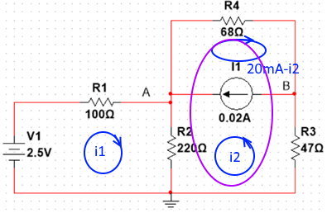





### Node & Mesh Analysis with Dependent Sources

These methods work the same with dependent sources; just take care to solve for the source variable and substitute that back in as a separate equation if necessary.

### Superposition

Method:

1. Remove all the [independent] sources except 1 (replace voltage sources with shorts and current sources with opens; i.e., set their numerical values to '0')
2. Solve for the value of current / voltage of interest produced by just that one source
3. Repeat for the other [independent] sources
4. Since the circuit elements are linear, the total response from all the sources would be the sum of the responses the sources produce by themselves.

Exception: Since *dependent* source values depend on the values of voltage / current in the circuit elsewhere, you need to leave them on when using superposition for each of the other sources.

Note that superposition relies on linearity, so it won't work for nonlinear quantities (i.e., since power is quadratic in voltage / current, the total power dissipated by an element is *not* in general the sum of the power dissipated in from source 1 alone + power dissipated in it from source 2 alone. Another example where it won't work is a circuit containing a nonlinear dependent source.)

Superposition is often the fastest method if you only need one specific value from a circuit (i.e., the voltage across a single resistor) since removing the other sources lets you combine resistors you don't need details for and sometimes even ignore entire branches and obtain solutions by ***inspection***.

However, if you need *all* the current and voltage values in a circuit it typically takes the longest.

Example: Find the voltage across and current through R2 in the following circuit using superposition



First, set the current source to 0 and solve for what the voltage source does by itself:

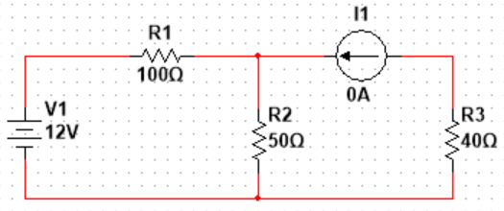

A 0-current branch is the same as an open circuit:

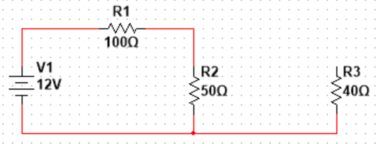

This is a voltage divider, which says , and 

Next, set the voltage source to 0 and solve for what the current source does by itself:

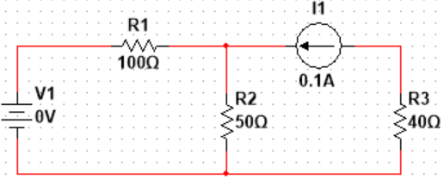

A 0-voltage branch is the same as a short circuit:

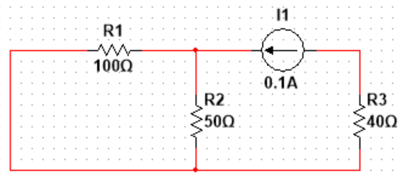

This is a current divider:  with voltage of .

Superposition says that the total current is the sum of the current each source would produce through R2 by itself, and similarly for voltage across it. Therefore in total,  and .

Below is another circuit solved via superposition (Taken from sample lab 1):

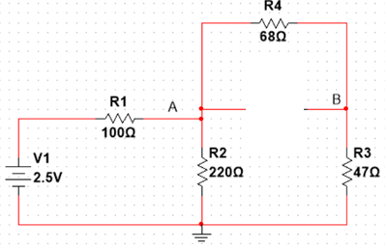

 (where )



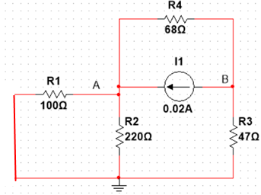

, where 

, and 

Total:



### Methods for Simplifying Source Networks

#### Thévenin's Theorem

Any one-port (i.e., two places to connect to it; high and ground) linear network can be replaced by an "equivalent" network consisting of a voltage source in series with a resistor, called the Thévenin voltage and Thévenin resistance.

(To say the source network is "equivalent" to its Thévenin equivalent means it does the same thing to any load attached to it; it may use more power than its Thévenin equivalent does so it's not "equivalent" to the actual source network in all ways.)

*[Note that the Thévenin equivalent of a network is unique; no other value of VTh or RTh in the equivalent circuit it would behave exactly the same for all loads.]*

This suggests how to find the Thevenin equivalent circuit:

1. Perform some experiment on the actual network and find how it responds.
2. Write that the equivalent circuit must react in the same way.

Repeat this until you have both VTh and RTh.

Examples:

1. Open circuit the output & find actual output voltage (remove the load). Output voltage of the equivalent network is VTh, therefore VTh is the output voltage you got.
2. Short circuit the output & find output current. Output current of the equivalent network is VTh/RTh, therefore that's equal to the output current you got.
3. Apply 1V supply to the output & find change in current it produces (e.g., using superposition; turn off sources inside the network); ; which, if there's no dependent sources in the network, is the same as finding the equivalent resistance looking in after zeroing the independent sources inside.

#### Norton's Theorem/Example

Norton’s theorem is the same as Thévenin's theorem except with a current source in parallel with a resistor. By applying the theorems together, it must be that , and .

Example: Find the Thévenin equivalent source network seen by R2 in the following circuit, and use it to calculate the voltage across and current through R2.



Solution:

The Thévenin equivalent source network seen by R2 is the network that R2 is attached to; so, replace it with terminals and redraw to see this clearly:

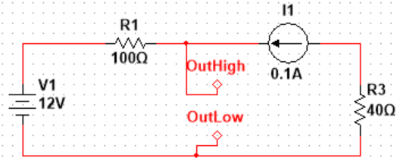

Equivalent Drawing:

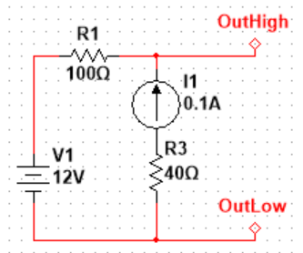

The Thevenin equivalent of this (or any) circuit looks like this:

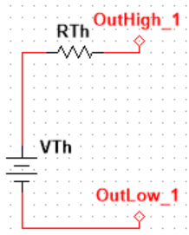

If it's equivalent to the other circuit, then it must produce the same voltage and current for any load placed across the output. For example, an open circuit output. In this case,  and so the Thevenin equivalent produces V­Th­ across the output (there's no voltage drop across the resistor), while the actual circuit of interest produces (looking at the left branch of the circuit) . Therefore, .

On the other hand, if you short the output (put 0 V across it), the Thevenin equivalent outputs a current of , while the actual circuit produces . Therefore , meaning the Thevenin equivalent is:

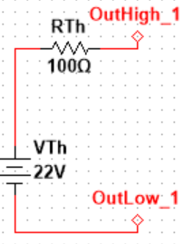

We also solved for the Norton equivalent during this process:

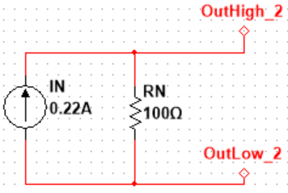

Now we can use either of these to find the voltage & current that the equivalent source network (and therefore the actual source network) puts across & through :

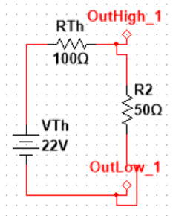

Therefore,



Note: since in this example the actual network has no dependent sources we could use the trick of zeroing the sources to find RTh­ by inspection:

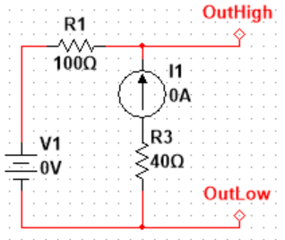--> 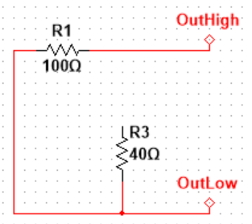

.

Notice also that the Thévenin equivalent network is not a very fast way to determine what the output of the source network will be for a specific load resistor. It really shines when you need to find the output across a wide variety of load resistors. E.g., now we can quickly determine the output if  were  instead of 50:



This quick solution advantage means we can do some theoretical work for Thévenin equivalent networks (like max power transfer & load lines in the next two sections) and as long as you know how to find the equivalent network you know how to apply the results to any source network.

Below is another example of how to reduce a circuit to it’s equivalent Thevenin and Norton circuits (Taken from sample lab 1):

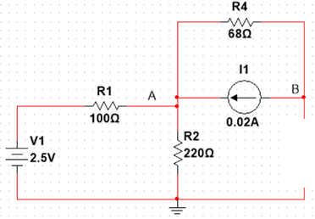







### Impedance Matching and Max Power Transfer

Consider a source network in its Thévenin equivalent form. The current delivered to the load resistor is , and the voltage across it is , so the power dissipated in it is .

Which load resistor will the source network deliver the most power to?

If you put the load resistor to infinite, then zero current flows; the denominator dominates and the power out is zero.

If you put the load resistor to zero, then no voltage is across it (all the power is dissipated in RTh instead of the load), and the power out is also zero.

The load resistance for "maximum power transfer" must be somewhere in the middle. Taking a derivative of  with respect to  and setting it to zero reveals the critical point:

Maximum power transfer occurs when .

This is called "**impedance matching**".

*Q: How much voltage appears across the load if it is impedance matched to the source resistance?*

Solution: VTh/2.

*[Note: We don't need to worry about it for low frequencies and short wires, but AC signals are actually EM waves travelling in wires. When you connect a source to a higher (non-matched) load resistor the change in propagation rate will cause the wave to reflect, which can create standing waves (similar to an increase of index of refraction for higher frequency light). The wavelength of 1 MHz EM waves is 300 m so isn't usually a problem, but at 1 GHz EM wavelength is only 0.3 m, which is a real concern. Therefore, a lot of care needs to be taken to do microwave frequency electronics correctly and impedance matching is a part of it. Because of this, outputs on high frequency instruments will typically tell you their impedance and will often read out their voltage as if they're being put into a matched resistor.]*

#### Load-Line Analysis of nonlinear circuits (a peek into 3BA4)

When dealing with non-linear circuits, it is helpful to graphically represent the I-V relationship for a given (non-linear) load. This is first done by finding the Thevenin equivalent of the linear portion of the circuit. Once this is done you can determine what’s called a “Load-Line” for the circuit.

The load-line equation is as follows:

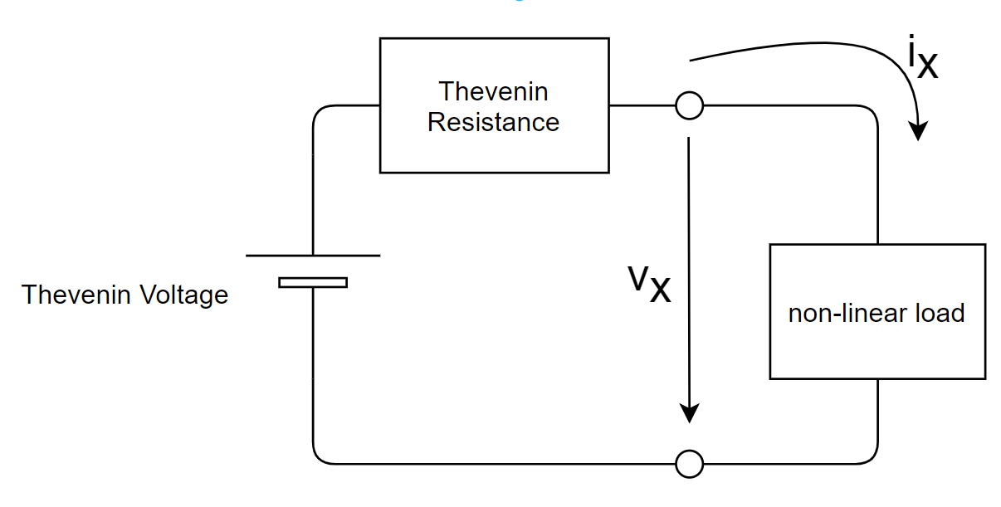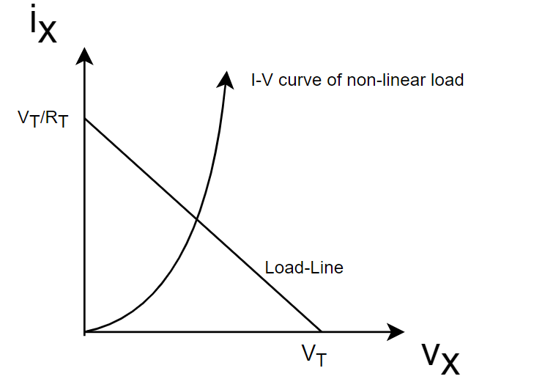

If you know the I-V relationship for the non-linear circuit element in question (usually an exponential), you can set it equal to the load-line equation. Maximum power transfer occurs at the solution of the two I-V curves shown above.

## Measurement Uncertainty and Error Propagation

Suppose you build the following circuit on a breadboard:



Analytically, you calculated the current through and voltage across R2 as:





Question: *Will this circuit really have these values when you assemble it?*

Answer: *Yes… but you won't find that, because you can't measure the values perfectly, and you can't actually assemble exactly this circuit.*

### Resistance Measurement

Resistors are manufactured to a certain tolerance, so that a 1 k resistor you get out of the box is not necessarily 1 k, but possibly 1.01 k, 1.05 k, 0.97 k, 1.12 k, or even 47 k if you picked the wrong box or the previous person didn't put it back properly. So it's a good idea to measure your resistors before building your circuit using them to find out what they really are.

Before assembling the circuit, you measure the values of the resistors using a multimeter with the following specifications:

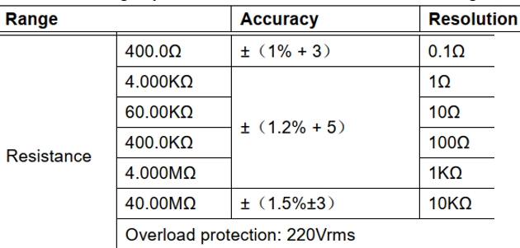

For the resistors, R1, R2, and R3, you measure values of 100.0, 49.2, and 42.1 Ω, respectively.

Based on the decimal reported, the ohmeter must've been on the 400.0 Ω range. On this range, the accuracy is 1% +3, meaning "1% of the reading +3 of the last decimal reported"; i.e.,

|  |  |  |  |
| --- | --- | --- | --- |
| Measure  [Ω] | 1% of reading  [Ω] | 3 of last decimal  [Ω] | Total uncertainty [Ω] |
| 100.0 | 1 | .3 | 1.3 |
| 49.2 | .492 | .3 | .792 → .8 |
| 42.1 | .421 | .3 | .721 → .8 |

Note: it's good to not assume that you know more than you really do with measurements, so the uncertainty .792 and .721 both round up if we're reporting them as a final result. e.g., we can say we measured:

R1 = (100.0 ± 1.3) Ω

R2 = (49.2 ± 0.8) Ω

R3 = (42.1 ± 0.8) Ω

(see the [Nist formatting guide](https://physics.nist.gov/cuu/Units/checklist.html) as a reference for this and other ways to report quantities with units)

Using the measured rather than the ideal resistor values and recalculating (using any of the circuit analysis methods above), we can update the prediction for the output voltage and current to

7.25 V

0.147 A

### Voltage and current

For voltage and current, the meter has the following specs:

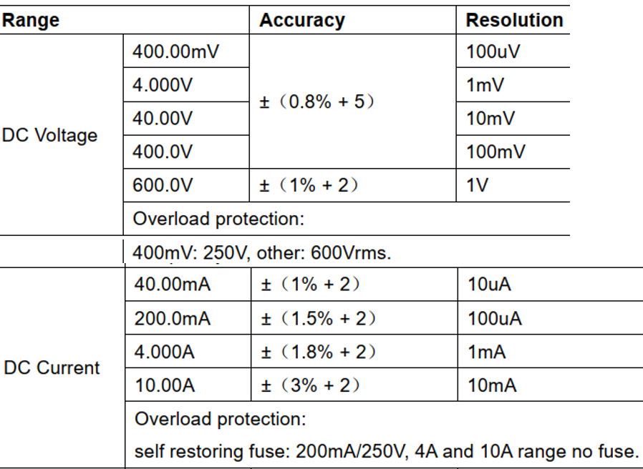

Suppose we measure VR2 using the voltmeter and get 6.60 V. This is on the 40.00 V range (based on the decimals reported), so has an uncertainty of 6.60*.8% + 5*0.01 = 0.13 V. This means our measure is really (6.60 ± 0.13) V.

For current, we measure 135.2 mA, which is on the 200.0 mA range meaning the uncertainty is 135.2*1.5/100+2*.1; or 2.228 mA, which we'll report as (135.2 ± 2.3) mA.

Even within the uncertainty, these aren't in agreement with the expected values (7.25 V and .147 A)

Aha! The supplies! Similarly measuring *V*1 reveals it to be (11.30 ± 0.14) V measuring *I*1 gives (90.1 ± 1.6) mA. If we use these measured values of supplies (along with the measured resistors) and recalculate we obtain calculation VR2 = 6.70 V and IR2 = 136 mA, which are now within the tolerance of the measured results.

Could we have found that the direct calculation was not in range of the measured values but still concluded that they agreed within the accuracy of our measurements? To find out, we need error propagation.

### Error Propagation

The calculation at the end of the previous section to obtain VR2 = 6.70 V and IR2 = 136 mA was based on input resistor values and supply voltage & current that had uncertainty in them, so we can't really be so certain about these calculated results and should propagate the error in the inputs through the calculation to find out the uncertainty in these calculated values.

#### Brute Force Method

One way to find the uncertainty in the calculated quantity is by brute force: redo the calculation for all possible values of the inputs in range and see what range we get on the outputs. Since the calculation here involves solving linear systems, we can simplify this and look at the values that make the output largest or smallest independently. i.e., recalculating with V1 = 11.44 gives a higher VR2, so (at least around the range of the measurement) VR2 must be increasing with V1, and we need the largest V1 to get the largest VR2. Repeating for all other inputs, we find the largest VR2 with the following inputs:  
**> restart:**

**V1:=11.30+.14: I1:=(90.1+1.6)/1e3:**

**R1:=100-1.3: R2:=49.2+.8: R3:=42.1+.8:**

**solve([**

**I2+I1=I3,**

**V1=VR2+VR1,**

**VR2+VR3=VI1,**

**VR1=I2*R1,**

**VR2=I3*R2,**

**VR3=I1*R3]):**

**assign(%):**

**VR2;**



(R3 has no effect).

Thanks to the linearity of this system and the small range of the errors, the lowest value of VR2 is at the opposite of each input range:

**> restart:**

**V1:=11.30-.14: I1:=(90.1-1.6)/1e3:**

**R1:=100+1.3: R2:=49.2-.8: R3:=42.1+.8:**

**solve([**

**I2+I1=I3,**

**V1=VR2+VR1,**

**VR2+VR3=VI1,**

**VR1=I2*R1,**

**VR2=I3*R2,**

**VR3=I1*R3]):**

**assign(%):**

**VR2;**



This means that, considering the uncertainty, our calculated value of VR2 is the average of these ± the distance to the edge of them; i.e., (6.70 ± 0.19) V.

Note: As you'll see in a stats course, this method of brute force checking extreme range of errors only works if you view the uncertainty as a hard tolerance where the real measure has no chance of being outside of the range and want to find a corresponding absolute range on the calculated quantity. Most of the time, a measurement uncertainty is due to a large number of independent random statistical processes (e.g., thermal fluctuations) and the tolerance ranges are instead representing statistical quantities. In this case, adding two quantities with the same uncertainty does *not* add the uncertainty on the product, but instead they should add in quadrature (because each is more likely to be near its centre, the chance that *both* are at an edge is correspondingly less likely than either one being there, so the 95% edge of the product is closer than the product of each 95% edge).

#### The Error Propagation Equation

A more sophisticated way to find the error in a calculated quantity like this is using the **error propagation equation**, which uses partial derivatives and knowledge of the analytical calculation you're using.

To find the analytical calculation, you can either work out the problem analytically from the start (like we did in the earlier sections), or use a computer algebra system (e.g.,

**> restart:**

**#V1:=11.3: I1:=.0901:**

**#R1:=100: R2:=49.2: R3:=42.1:**

**solve([**

**I2+I1=I3,**

**V1=VR2+VR1,**

**VR2+VR3=VI1,**

**VR1=I2*R1,**

**VR2=I3*R2,**

**VR3=I1*R3], [I2, I3, VI1, VR1, VR2, VR3]):**

**assign(%):**

**VR2;**



, matching ).

With the analytical formula, we can compute the change in  in response to an infinitesimal change in each of the input variables using a linearization:



This means that the maximum magnitude of change in VR2 in response to a possible change magnitude  in each of the inputs is:



Therefore, if we substitute the values of the inputs into this and use the uncertainty on the inputs as the differential changes in them, this corresponding change magnitude on the output will equal the uncertainty on the output (i.e., the maximum magnitude of change on the output we can produce from a change in the inputs within their uncertainty). (Note that this assumes the uncertainties are small enough that approximating them as differential changes is valid).

This is the error propagation equation. It lets us find (for sufficiently small uncertainties) the uncertainty on *VR2* in terms of the partial derivatives of its analytical formula (evaluated at the centre of the measurements) and the uncertainty in each input:

**> restart:**

**#V1:=11.3: I1:=.0901:**

**#R1:=100: R2:=49.2: R3:=42.1:**

**solve([**

**I2+I1=I3,**

**V1=VR2+VR1,**

**VR2+VR3=VI1,**

**VR1=I2*R1,**

**VR2=I3*R2,**

**VR3=I1*R3], [I2, I3, VI1, VR1, VR2, VR3]):**

**assign(%):**

**VR2;**

**dVR2=abs(diff(VR2, V1))*dV1+abs(diff(VR2,I1))*dI1+abs(diff(VR2,R1))*dR1+abs(diff(VR2,R2))*dR2;**

**evalf(subs([V1=11.3, dV1=.14, I1=.0901, dI1=.0016,**

**R1=100, dR1=1.3, R2=49.2, dR2=.8], %));**







Which matches the 0.19 V we found by brute force. Again this method takes the errors as hard ranges rather than statistical distributions, but the error propagation equation can extend to dealing with statistical errors too (by working in quadrature, as you'll see in a stats course).

Note: If you can evaluate your calculation output but don't have an analytical formula for it, you can still do this method by numerically calculating the partial derivatives using small changes:  for sufficiently small .

You'll see much more on approximating derivatives like this in your numerical methods course.

Thus, since our calculated value was actually (6.70 ± 0.19) V, we could have still concluded the measurement and calculation agreed as long as the ranges from each overlapped (e.g., we measured 6.99 ± 0.11). If they aren't within this range of each other, then there is likely something deeper going on with the circuit; e.g.,

1. the circuit is not connected like it's supposed to be,
2. we made a mistake in measuring one of the earlier values,
3. the values have changed from what they were when we measured them (possibly due to temperature change),
4. bad connections are making contact resistance (the electrical resistance that shows up jumping from one solid to another) significant

##### Reconciling Error Propagation from Level 1

In first year physics you were told that when you add quantities the uncertainty on the result is the sum of the **absolute** uncertainties but if you multiply quantities it's the sum of the **relative** uncertainties. Can you reconcile this information with the error propagation equation?

Absolute uncertainty is the type of uncertainty we've been dealing with; if , then  is an absolute uncertainty.

Relative uncertainty means this uncertainty expressed as a fraction of the measured value; i.e., the corresponding relative uncertainty is .

Suppose we measure two values *u* and *v* and want to compute two functions from them:  and .

Using the error propagation equation, the uncertainties on these quantities are:



and



Using the rules from level 1 physics, the uncertainty on *f* is  (sum of abs uncertainties), and on *g* is , which match the results produced by the error propagation equation. Reconciled!